EROSION – TRANSPORT OF WEATHERED MATERIAL

EROSIONAL AGENTS: Running water, glaciers, wind, ocean currents and waves and mass movement/gravity.
What happens to rainfall when it hits earth?
- Some evaporates
- Some is absorbed and becomes ____________
- Some is run-off
RUN-OFF
- Steep Slope or____________ of the Land
- Saturated soil
- Vegetation – amount of plants
- Rainfall greater than infiltration rate
Running Water
Most of North America is above sea level. Water flows high to low sea level. Streams – run-off confined to a channel
- Smaller stream that flows into a larger stream is called a __________
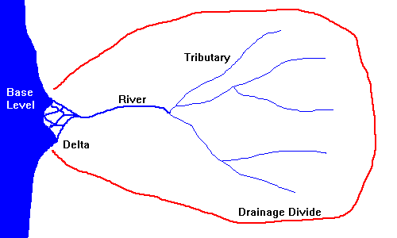
- Tributaries and land that contribute to the stream is called a drainage basin or _________
- The drainage basin of one stream is separated by a drainage divide (ridges or mountains – areas of higher elevation)

Streams carry sediment:
- Solution: _____________ material (includes salts – cannot see these ions of Na+ and Cl-)
- Suspension: particles carried in the flow of the water (_____ ,silt, sand)
- Bed load: particles carried by rolling, bouncing, or dragging along the stream bed (__________, cobbles, boulders)
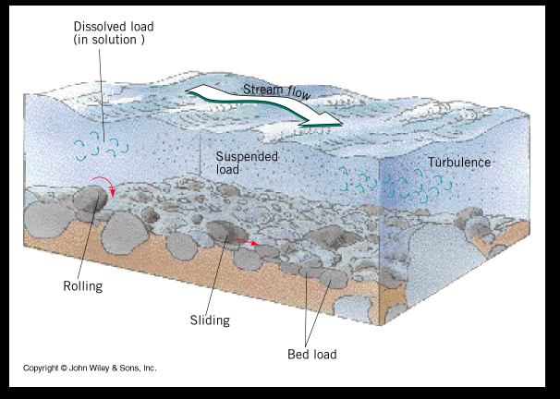

Abrasion of bed load – rolling, bouncing, sliding knocks the corners off sediment – becomes rounded
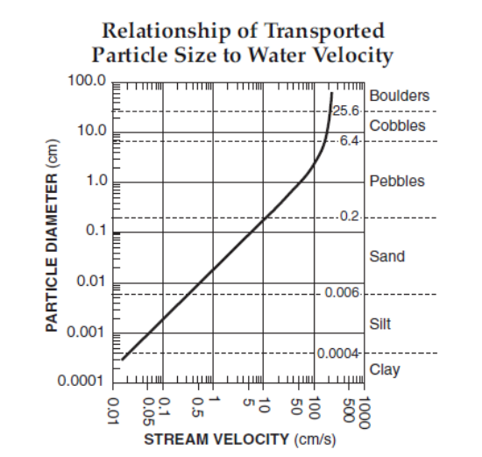
Water Velocity determines the size particle that can be moved via suspension and bed load

Greater the velocity:
1. Larger sediment can be transported
2. More sediment can be transported

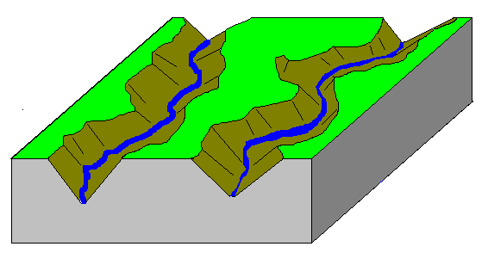

Stream Development – Landscape continually being reshaped by streams
YOUTHFUL
- Over time, streams carve deeper channels transforming the landscape into a _____ - SHAPED VALLEY
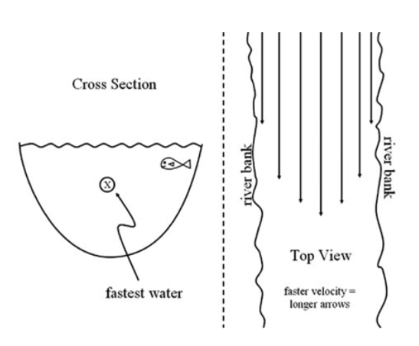
- Waterfalls and Rapids
- Straighter channels
- NO FLOOD PLAIN

Stream Velocity in a Straight Channel
Fastest – ________just below surface

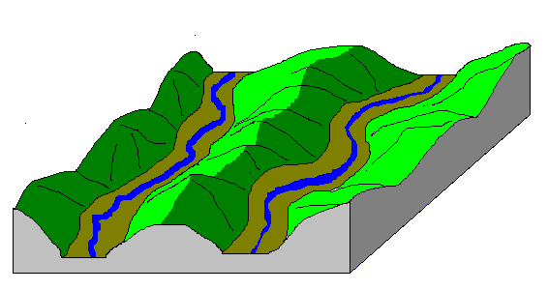
MATURE
- Lateral (side to side) erosion widens the valley
- River bends become more pronounced producing bends called MEANDERS
- A _____ _______begins to form on the valley floor.

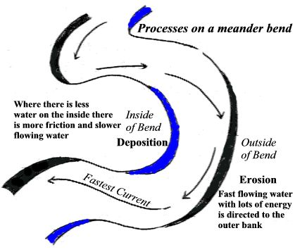
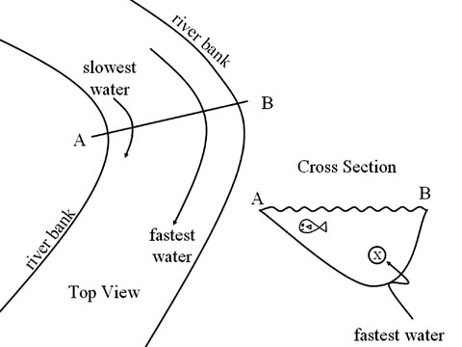
Velocity in a Curve – Meander (bend)
Fastest on the outside of curve – erosion (CUTBANK FORMS)

The inside of the curve – deposition
(POINT BAR DEPOSIT FORMS)
Old Age – Very wide floodplain, _________ lakes, and deltas form
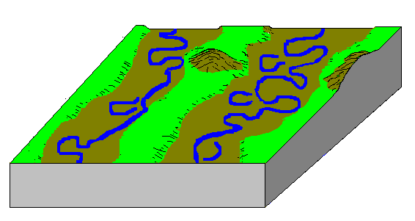

Sediment characteristics of erosion by water
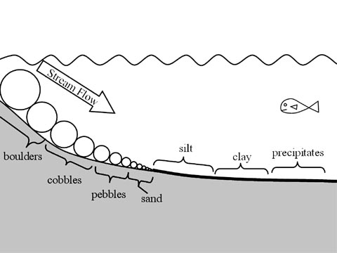
_________, smooth, sorted (all materials the same size), layered

Horizontal Sorting: When a stream enters a large body of water or velocity slows gradually – the ________ particles are dropped first and smallest last.
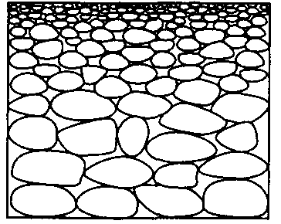

Graded Bedding: larger, denser, rounder sediments dropped first – annual spring thaws, landslides

Ocean Currents and Waves
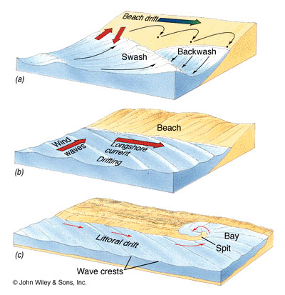
Long shore current: water near shore pushed in one direction: ERODES AND DEPOSITS

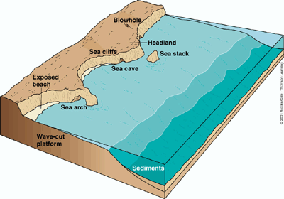
Erosion: Caves, steep beaches

Deposition: spits, sand bars

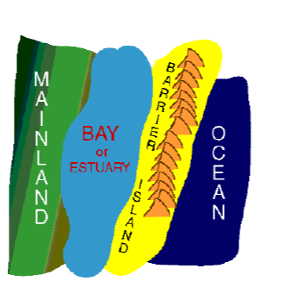
Barrier Islands (Fire Island) formed by long shore current
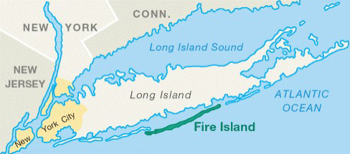

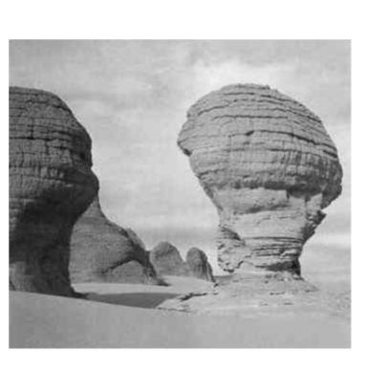
Wind Erosion – deflation and abrasion/sandblasting – “mushroom rocks” – frosted and pitted sediment characteristics
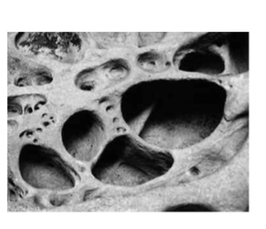

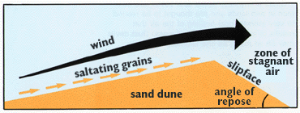
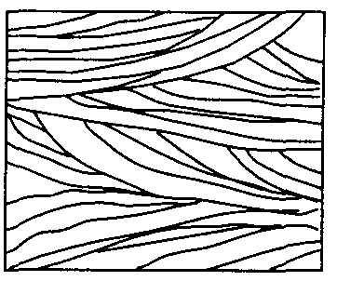
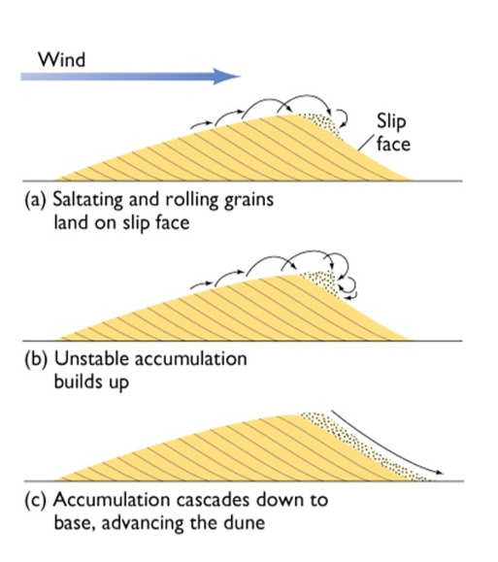
Sand dunes – know which way winds blow to form

Cross bedding in sand dunes

